


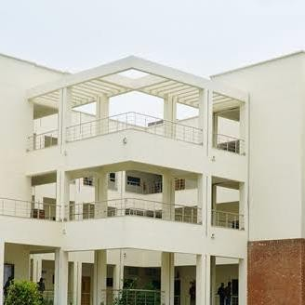
GROUP MEMBERS:
SUBMITTED TO: MS. MINA

DSA LAB

- Aneela Sarwar FA24-BCS-182
- M Okasha FA24-BCS-187
- Maheen Akhtar FA24-BCS-198
- Hassan Arshad FA24-BCS-199
Comsats University, Islamabad (Sahiwal Campus)
DSA LAB
TASK A:
#include <iostream>
#include <conio.h>
#include <windows.h>
#include <ctime>
using namespace std;

const int ROWS = 20;
const int COLS = 40;

struct Node {
int r, c;
Node* next;
};

Node* head = NULL;
Node* tail = NULL;
int snakeLength = 3;

int dr = 0, dc = 1;

int foodR, foodC;

void insertHead(int r, int c) {
Node* newNode = new Node{r, c, head};
head = newNode;
if (tail == NULL) tail = newNode;
}

void insertTail(int r, int c) {
Node* newNode = new Node{r, c, NULL};
if (head == NULL) {
head = tail = newNode;
return;
}
tail->next = newNode;
tail = newNode;
}

void removeTail() {
if (head == NULL || tail == NULL) return;

if (head == tail) {
delete tail;
head = tail = NULL;
return;
}

Node* temp = head;
while (temp->next != tail)
temp = temp->next;

delete tail;
tail = temp;
tail->next = NULL;
}

bool checkCollision(int r, int c) {
Node* temp = head;
while (temp != NULL) {
if (temp->r == r && temp->c == c) return true;
temp = temp->next;
}
return false;
}

void placeFood() {
foodR = rand() % ROWS;
foodC = rand() % COLS;
}

void drawBoard() {
system("cls");

for (int i = 0; i < COLS + 2; i++) cout << "-";
cout << endl;

for (int r = 0; r < ROWS; r++) {
cout << "|";
for (int c = 0; c < COLS; c++) {

bool printed = false;
Node* temp = head;

while (temp != NULL) {
if (temp->r == r && temp->c == c) {
cout << (temp == head ? "S" : "o");
printed = true;
break;
}
temp = temp->next;
}

if (!printed && r == foodR && c == foodC) {
cout << "@";
printed = true;
}

if (!printed) cout << " ";
}
cout << "|" << endl;
}

for (int i = 0; i < COLS + 2; i++) cout << "-";
cout << endl;

cout << "Length: " << snakeLength << " (use W S A D to move)\n";
}

void moveSnake() {
int newR = head->r + dr;
int newC = head->c + dc;

// Wall
if (newR < 0 || newR >= ROWS || newC < 0 || newC >= COLS) {
cout << "GAME OVER! Hit the wall.\n";
exit(0);
}

// Self (except tail)
Node* temp = head;
while (temp != NULL && temp != tail) {
if (temp->r == newR && temp->c == newC) {
cout << "GAME OVER! You hit yourself.\n";
exit(0);
}
temp = temp->next;
}

insertHead(newR, newC);

if (newR == foodR && newC == foodC) {
snakeLength++;
placeFood();
} else {
removeTail();
}
}

void handleInput() {
if (_kbhit()) {
char ch = _getch();

if (ch == 'w' && dr != 1) { dr = -1; dc = 0; }
if (ch == 's' && dr != -1) { dr = 1; dc = 0; }
if (ch == 'a' && dc != 1) { dr = 0; dc = -1; }
if (ch == 'd' && dc != -1) { dr = 0; dc = 1; }
}
}

int main() {
srand(time(0));

insertTail(10, 10);
insertTail(10, 9);
insertTail(10, 8);

placeFood();

while (true) {
drawBoard();
handleInput();
moveSnake();
Sleep(120);
}
return 0;
}

TASK B: (TESTING)

Normal Inputs
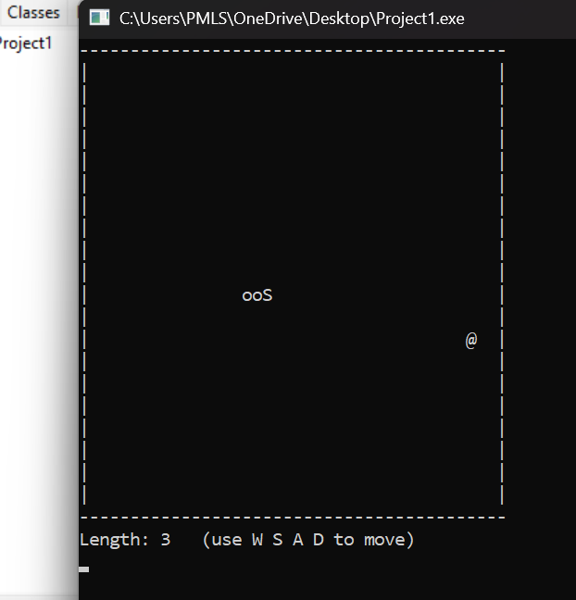

Incorrect Inputs:
Edge Case:
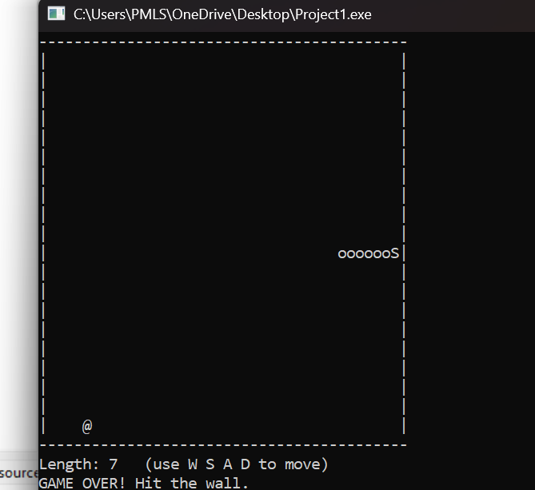

Task C - Kaizen Review Table
What was built | Problem Found | Improvement Idea | Impact
Snake Movement | Lagging when snake grows | Use structure  instead of std::deque | Faster processing
Food Logic | Food spawning on snake body | Add a check loop for food position | Better gameplay

Task D - Eisenhower Matrix
Quadrant | Tasks
Urgent + Important | Complete Task A (Core Features) & Fix bugs in Snake movement.
Important + Not Urgent | Update LinkedIn Profile & GitHub Readme.
Urgent + Not Important | Taking screenshots of the game for Task B.
Not Urgent + Not Important | Decorating the console colors or extra sound effects.

Task F – LinkedIn Proof
